**Steps to use the Occupancy Simulator measure in OpenStudio**

Han Li

2018-11-08

1. **Prepare an OpenStudio model**

Example: create an ASHRAE reference small office model with the “Create DOE Prototype Building” measure

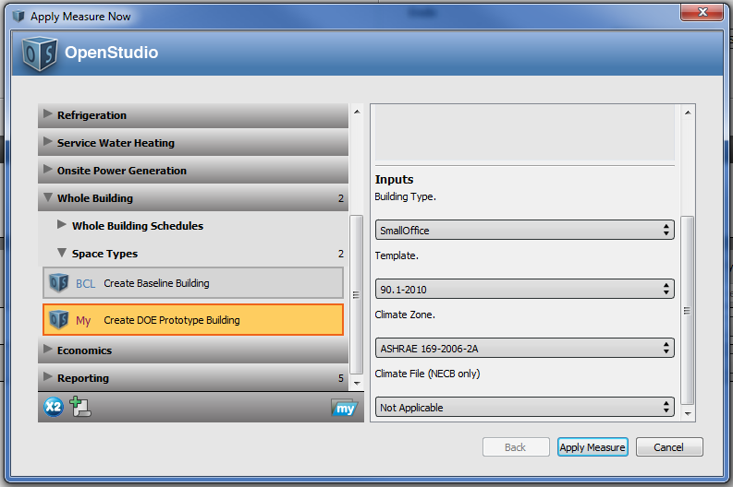

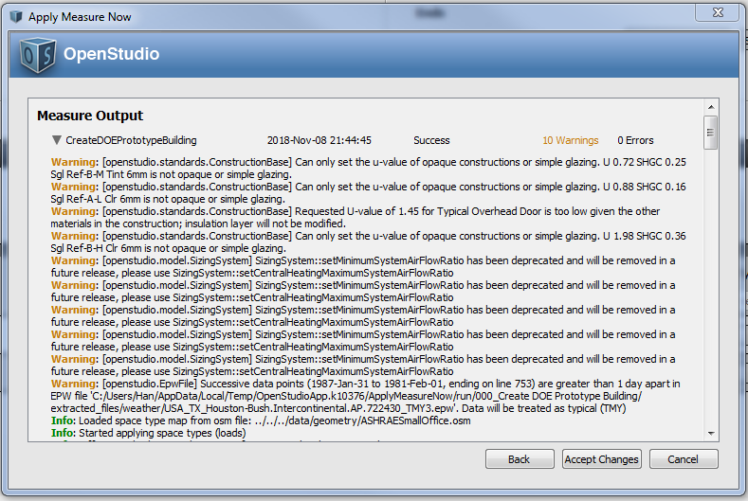

1. **Define rules (optional)**

We provide a pre-defined library of space, occupancy, and holiday rules. Power-users can customize the pre-defined rules.

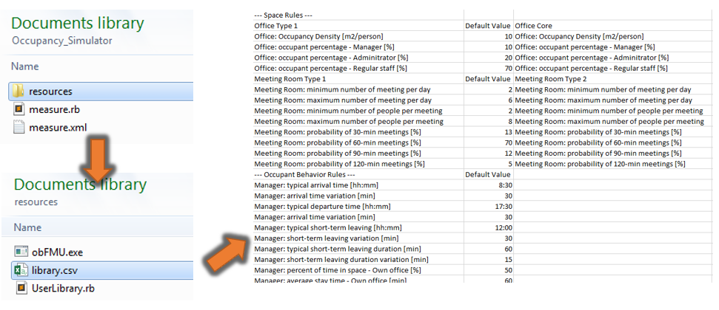

1. **Apply the Occupancy Simulator measure**

There are two approaches to apply the measure in OpenStudio App

**Approach 1**:

Choose the Occupancy Simulator measure under the “People” category. By default, the measure will auto-fill the space type assumption for each space based on its standard space type in OpenStudio. User can choose different space type assumption in the drop-down list. Those assumptions are based on the rules in the pre-defined library mentioned in step 2. In this approach, OpenStudio will generate stochastic occupancy schedules only.

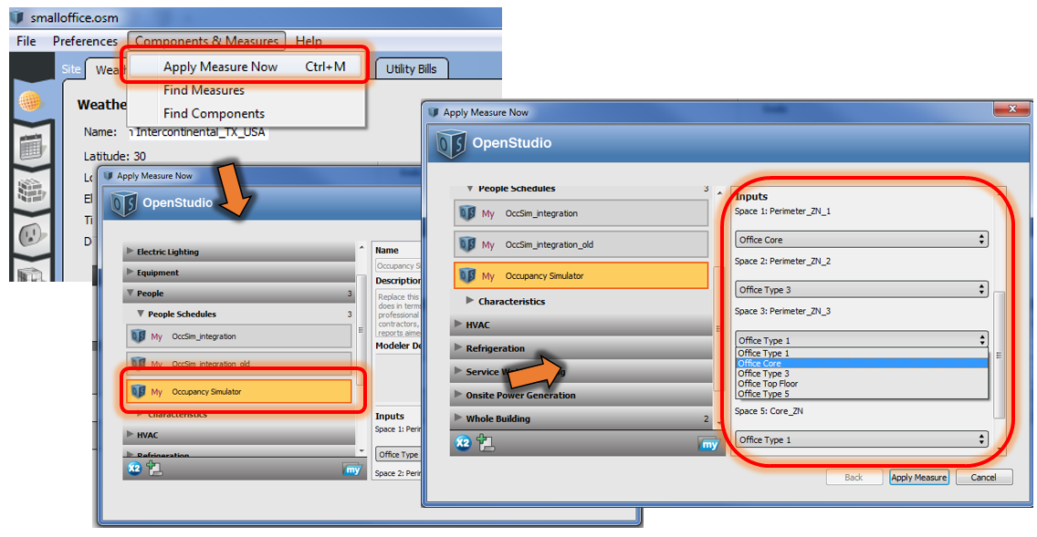

**Approach 2**:

Choose the Occupancy Simulator measure under the “Measure” tab. Provide measure inputs like in approach 1. Run the measure in the “Run Simulation” tab. In this approach, OpenStudio will first generate the stochastic occupancy schedule for each space, and then run the simulation with updated occupancy schedules.

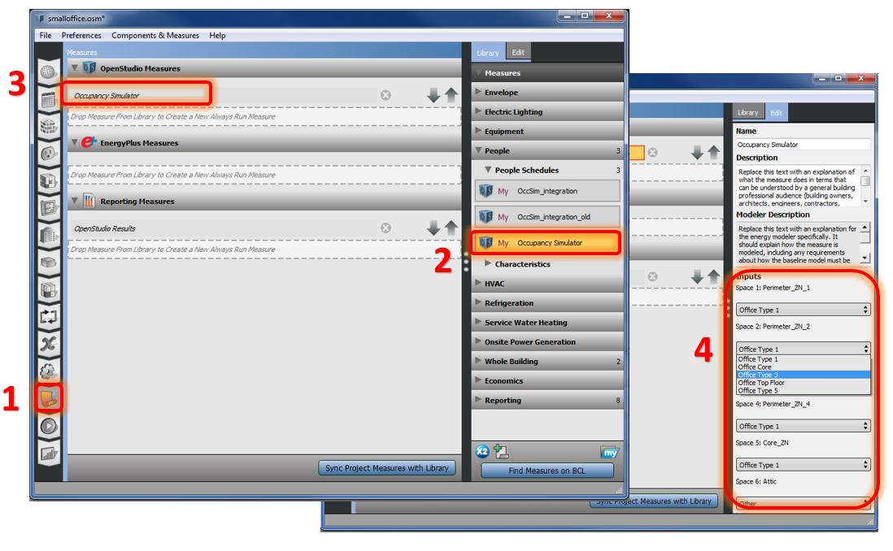

1. **Check the outputs**